# **Testing and Debugging for “Binary Bards”**

Iterative Development of Main Battle Loop

* Random Enemy Encounter:

-Had to use Unity’s in- built Random.Range function to randomize enemies

* Object initialize:

-Used a switch- case to initialize enemy units

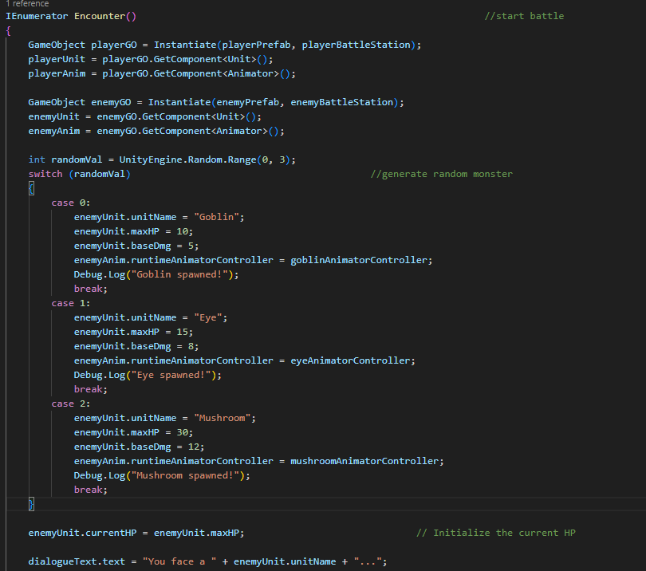

* Group Enemy Encounter:

- Spawned a monster according to size.

- Had to use a for loop to generate a random group size.

